REFORM INITIATIVES
Website Information Architecture Notes

RI operates across various thematic areas, ways of working, outputs and impact. The website therefore needs to function as a dynamic institutional platform and knowledge hub where visitors can understand the organization and the extent of its work easily. The Information Architecture is based on several principles:
- Thematic areas are the primary lens for understanding RI's work - The 4 thematic focus areas (Reparatory Justice, Human Rights, Transitional Justice, Democracy & Governance) function as a common taxonomy across the website. E.g. A Reparatory Justice research paper should appear in the central Insights & Resources repository, but should also automatically appear within the Reparatory Justice thematic page.
- Content design is based on clear language hierarchy - To maintain consistency and ease of understanding, the website will separate themes, approaches and outputs. Language will be understood as follows:
  - Our Work - the 4 issues and thematic areas RI works on.
  - How We Work - the approaches and methods RI applies within and across those thematic areas. (General organizational approach is presented separately as thematic approaches are embedded to thematic pages.)
  - Programmes/Projects - specific interventions undertaken under one or more thematic areas.
  - Insights & Resources - knowledge and communication outputs produced through RI's work e.g. Research reports, Policy briefs, Articles, Reports from convenings, Multimedia resources
  - Events - convenings, conferences, dialogues, festivals, roundtables and other events organised or participated in by RI.
- Dynamic content tagging for end-to-end information - Content will be tagged on attributes such as Theme, Resource type, Programme/project ensuring content appears across relevant pages to reduce time spent navigating between webpages. E.g. A policy brief on reparatory justice in Ghana could therefore appear automatically in the Insights & Resources → Policy Briefs; Our Work → Reparatory Justice → Latest Insights and; Relevant project page
- Simple Navigation - The primary navigation bar will not use dropdown menus. Navigation into deeper levels of the website will happen once a visitor arrives on the relevant landing page. E.g. Our Work will introduce the four thematic areas and direct users into each thematic page rather than presenting all four themes in a dropdown menu.
- The website should prioritise useful public-facing information - Not every piece of institutional information supplied by RI needs to become prominent website content. E.g. Operational capabilities such as subgranting is important but should be treated as latent information relevant within programme descriptions or partnership information, but does not need to become a major homepage message or top-level navigation item.
- Impact is embedded across the website, not treated as a standalone section (current) - Evidence of RI’s contribution, influence and results should be integrated into the Home Page, thematic focus areas, programme pages, Insights & Resources, and Events so that visitors encounter impact in the context of the work that produced it. As RI develops a larger body of structured results, evidence and outcome data over time, a dedicated Impact section can be considered in future iterations of the website
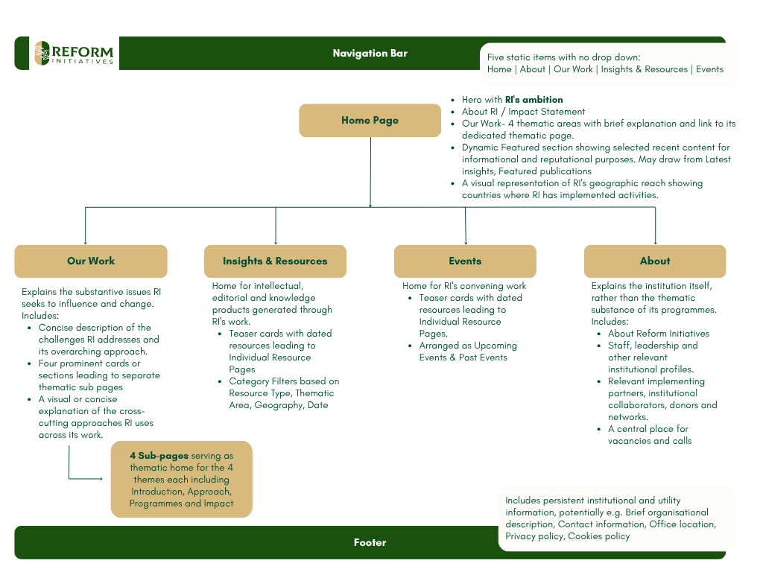
To be delivered:
- Brand Alignment Notes
  - Logo Update
  - Palette Refresh
  - Typography
  - Content Design
  - Strategic Confusion across the current website, info pack, and online presence

- Information Architecture - Site Map + Notes:
  - Separate Current blogs into Research & Insights
    - Research is Publications

- UX

Home (Logo) | About | Our Work/ Programs | Insights & Resources | Events

Home Page
- Hero Banner (Vision Statement - i.e. What is Reformed Initiatives trying to do without talking about the Org/Tagline with 1 or 2 CTA buttons - CTA could be impact) - see how to make hero interesting
- About RI & Impact Statement teaser
  - 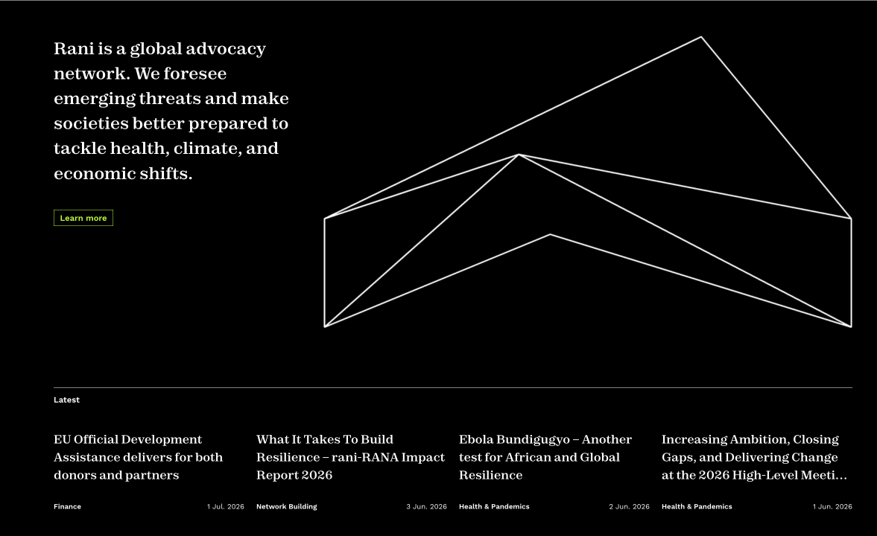
  - 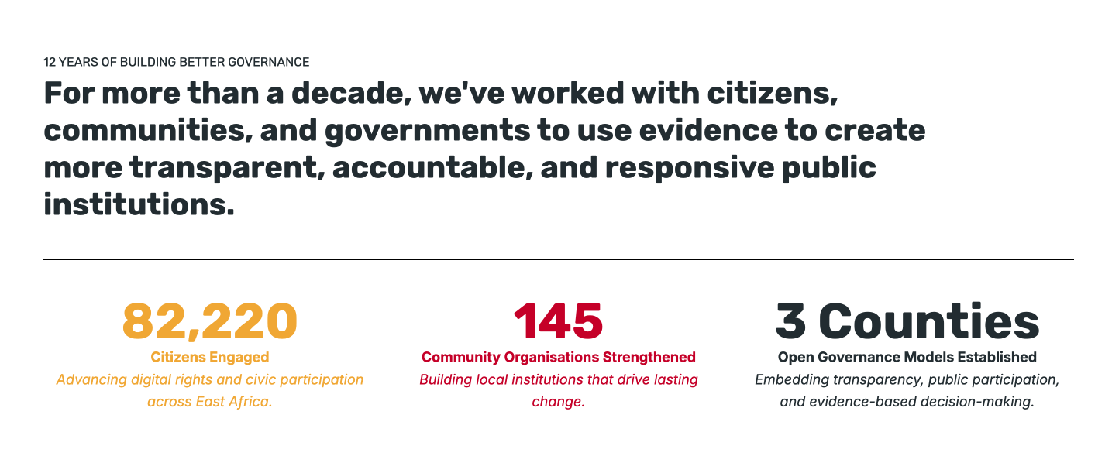
- Programs/What we do/Focus Areas/Priorities (Reparatory Justice, Human Rights, Transitional Justice, Democracy & Governance)
  - 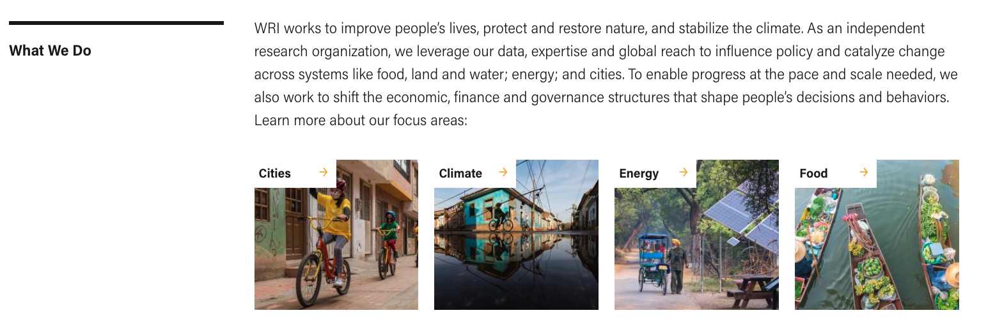wri
  - 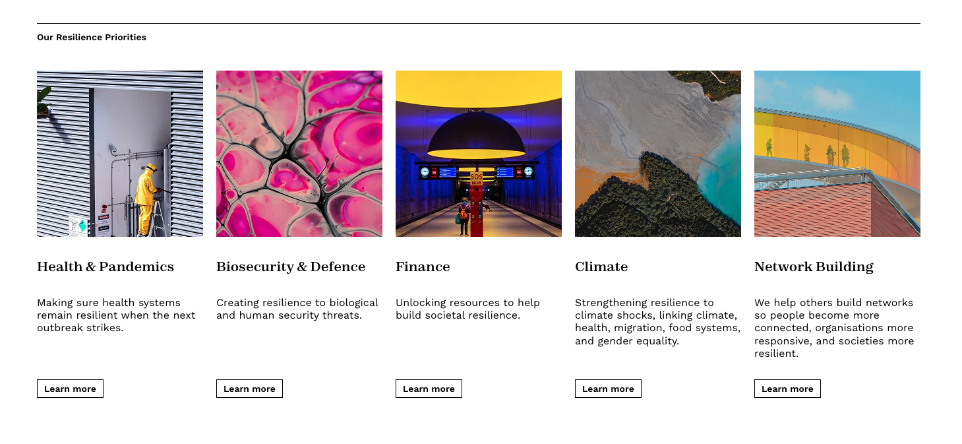 rani
- Featured/Latest
  - 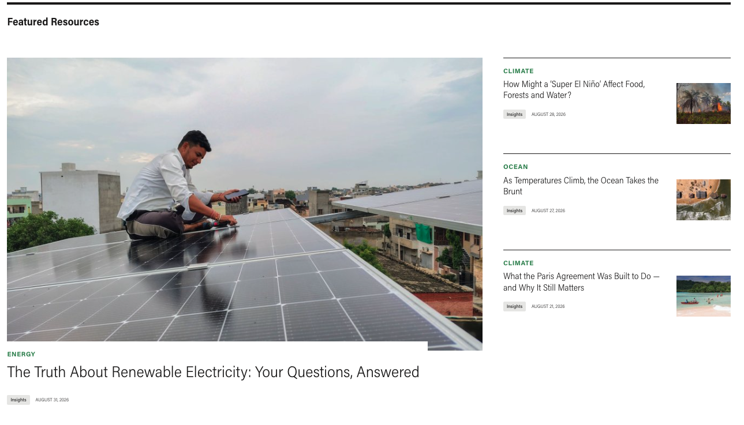
- Our Global Reach
  - 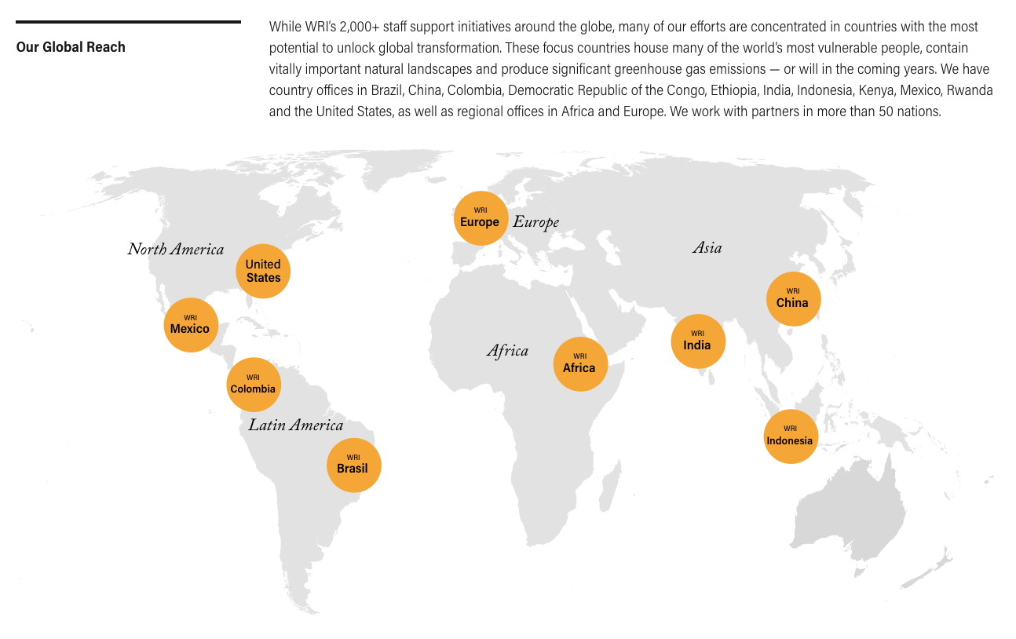wri
  - 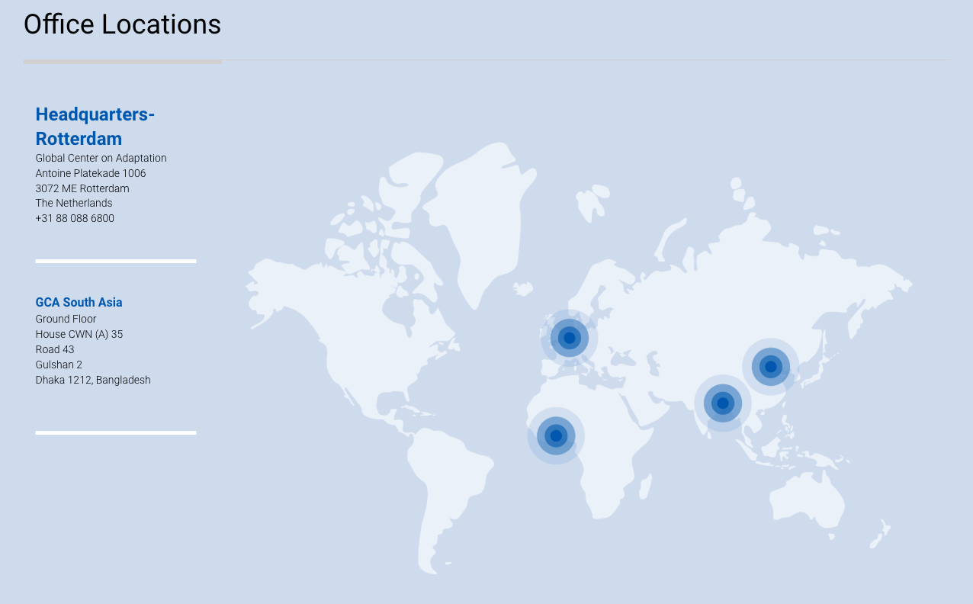gca
- Footer
  - Telephone: +233 55 336 9902
  - Email: info@reforminitiatives.org
  - Location: 3 Nii Ashitey Trebi Street, East Legon, Accra, Ghana
  - Digital Channels
  - See here
  - Impact

1. About Reform Initiatives

Who We Are
Reform Initiatives (RI) is an ethics-driven Pan-African institution advancing African discourses on reparatory justice, transitional justice, human rights, democracy, and good governance.
We are an independent, multi-thematic organisation undertaking non-partisan research, policy, advocacy, convening, and strategic engagement across Africa and the African diaspora. Our work is grounded in deep Pan-African values and supported by expertise spanning government, intergovernmental, civil society, media, technology, and philanthropic engagement.
Registered and licensed to operate in Ghana, Sierra Leone, and the United States of America, our work is transcontinental in scope, with partnerships and activities extending across Africa and beyond.

Telephone: +233 55 336 9902
Email: info@reforminitiatives.org
Location: 3 Nii Ashitey Trebi Street, East Legon, Accra, Ghana

Digital Channels
See here
2. Vision, Mission & Strategic Goal
Vision
A just and equitable future for Africans and people of African descent.
Mission
To accelerate African-led solutions that advance impactful reparatory and transitional justice for historical and contemporary injustices.
We do this by:
- Amplifying community-centred voices and initiatives by Africans and Afro-descendants across the world.
- Facilitating collaborative learning and knowledge exchange.
- Promoting progressive African narratives.
- Convening meaningful intergenerational and transcontinental dialogues.
- Building strategic connections between actors and institutions advancing justice, democratic accountability and sustainable reform.

Strategic Goal: To advance reparatory justice policies and sustainable reform processes while connecting relevant actors and institutions to amplify people-centred African solutions for reparations, transitional justice and human rights, while harnessing democratic dividends.

3. Core Values
- Professionalism & Ethics
- Integrity & Transparency
- Versatility & Quality
- Impartiality & Independence

4. What We Do
RI works across research, policy, advocacy, convening, communications and strategic partnerships.

Our work includes:
- Research and policy development on justice and governance.
- Strategic advocacy and global engagement.
- Convening dialogues, forums and high-level conversations.
- Digital campaigns and narrative change initiatives.
- Partnerships that connect movements, institutions and communities.
- Knowledge generation, skills incubation and ideas exchange.
- Engagement with media and technology actors to advance democratic and socio-political development.
- Financial and operational capacity support for civil society organisations.

How We Work
We employ a range of approaches to advance our institutional mission and goals, including partnership interventions, research, convenings, advocacy, knowledge exchange and capacity support.

Through research, we investigate the causes of issues, provide critical assessments and develop pragmatic, workable solutions. We create spaces for learning and exchange and work across sectors to build connections between institutions, movements, communities and individuals.
RI also undertakes consultancies in relevant fields to support our work and contribute to Africa's democratic and socio-political wellbeing.

We provide financial and operational capacity support to CSOs and NGOs through:
- Fiscal sponsorship/hosting for projects and CSO/NGO start-ups.
- Technical support in finance and operations.
- Training in financial management, grants management, financial sustainability and fiscal rules and regulations.
- Field project financial review and monitoring.
- Sub-grants management.

- Reparatory Justice and Healing
- Human Rights & Transitional Justice
- Democracy and Good Governance

Reparatory Justice  RI’s Reparatory Justice thematic area advances African-led approaches to confronting and addressing the historical and ongoing harms of colonialism, enslavement, exploitation and other systems of injustice. It brings together work on reparations, restitution, historical memory, justice, accountability, healing and African self-determination, while creating space for African actors to define what repair means within their own contexts.  Our approach is guided by the 6Rs framework:  - Reconnect with histories, identities, cultures, communities, lands and knowledge systems disrupted by historical injustice.  - Re-Education to reclaim knowledge, challenge dominant narratives and deepen understanding of African histories, contributions, resistance and lived experiences.  - Repair the material, political, social, cultural and psychological harms produced by historical and continuing systems of injustice, including through restitution, redress and accountability.  - Rebuild communities, institutions, systems and movements in ways that strengthen agency, dignity, resilience and self-determination.  - Resist structures, practices and narratives that continue to reproduce inequality, exploitation, dispossession and injustice, while strengthening collective action for change.  - Reimagine more just futures rooted in African agency, solidarity, dignity and self-determination, while creating alternatives to systems inherited from histories of domination.  Through this thematic area, RI serves as a facilitator, connector and platform for African-led reparatory justice efforts, bringing together movements, institutions, researchers, policymakers, cultural actors and communities working to advance justice, accountability, healing and repair. | Human Rights  RI’s Human Rights work focuses on advancing the protection, promotion and realisation of human rights across Africa. We collaborate with communities, individuals, civil society organisations, non-state actors and policymakers to address human rights challenges, prevent violations and strengthen systems that uphold dignity, equality, justice and accountability.  The programme creates space for RI to respond to emerging human rights concerns and evolving challenges across the continent, while supporting civil society-led approaches to addressing the complex crises affecting African societies.  RI seeks to strengthen connections between communities, rights actors and decision-makers, creating opportunities for lived experiences and community perspectives to inform policy and practice. | Transitional Justice  RI’s Transitional Justice work focuses on addressing the legacies of mass human rights violations and atrocities while supporting societies to build more peaceful, inclusive and just futures.  We work with communities, individuals, civil society actors, policymakers and other stakeholders to explore approaches to truth, justice, accountability, reparations, reconciliation, institutional reform and guarantees of non-recurrence.  Bringing partners and communities together to engage policymakers is central to our approach. RI supports dialogue and learning around transitional justice initiatives that can contribute to sustainable peace, strengthen accountability and ensure that responses to past and ongoing violations are grounded in the experiences and aspirations of affected communities. | Democracy & Governance  RI’s work on democracy and governance examines the barriers that prevent meaningful representation, participation and accountability.  Our hypothesis is that a lack of genuine representation of ordinary people, or representation without meaningful participation, can weaken checks and balances in governance, facilitate the misappropriation of resources and perpetuate colonial legacies.  Under this programme, we explore barriers to democracy and good governance across Africa, engaging people across generations to examine sustainable approaches to reforming local, regional and international governance systems, structures and processes.

5. Where We Work
Reform Initiatives' current work is focused on Africa, with activities and partnerships extending across the continent and the African diaspora.

RI is registered in:
- Ghana
- Sierra Leone
- United States of America

We have worked with partners in Sierra Leone, Ghana, United States, Namibia, The Gambia, Ethiopia, Liberia Senegal, Scotland, Zambia, Egypt, Colombia, Nicaragua, Jamaica, Barbados, etc.

Our work is transcontinental through partnerships, collaboration and knowledge exchange.

6. Selected Contributions & Impact
Since its establishment in 2023, Reform Initiatives has contributed to major policy processes, convenings, advocacy efforts and collaborative initiatives advancing reparatory justice, human rights, transitional justice and democratic governance across Africa and the diaspora.
The examples below provide a snapshot of RI’s work and contribution.

Wakati Wetu Festival
RI co-organised Africa’s first-ever festival dedicated to reparations, bringing together diverse stakeholders to advance dialogue, awareness and action around reparatory justice.

UN General Assembly Resolution
RI supported the Government of Ghana in drafting, negotiating and mobilising support for the adoption of UN General Assembly Resolution A/80/L.48, recognising the trafficking of enslaved Africans and racialised chattel enslavement as the gravest crime against humanity.

Accra Reparations Conference
RI served as the institutional rapporteur for the Accra Reparations Conference in November 2023. The Founder also participated in a panel examining the possibility of establishing a Global Reparations Fund based in Africa and contributed to the development of the Accra Proclamation.

Repairing International Development Conference
RI convened the Repairing International Development Conference, bringing together actors from across the Global Majority to examine how international development can be reimagined around indigenous knowledge, locally driven solutions and more equitable systems of development.

Roundtable Dialogue on Global Racial Justice | Brazil, December 2023
RI participated in a global roundtable convened by the Global Initiative for Justice, Truth and Reconciliation (GIJTR), the International Coalition of Sites of Conscience (ICSC) and the Centre for the Study of Violence and Reconciliation (CSVR). The dialogue brought together policymakers and civil society representatives working on racial justice, transitional justice and atrocity crimes.

AU Study Tour to Barbados | 2023
RI provided remote support to AU ECOSOCC and the Africa Judges and Jurists Forum (AJJF) for a learning tour to Barbados focused on reparatory justice, with support from the Open Society Foundations.

What’s Possible! | Ghana, February 2024
RI collaborated with the Children’s Rights Innovation Fund (CRiF) to co-host a three-day experiential convening bringing together more than 15 youth organisations from across Ghana.

Transforming Transitional Justice | Barcelona, March 2024
RI participated in GIJTR’s 10-year anniversary event, Transforming Transitional Justice: Innovative Approaches for Centering Communities to Lead Post Conflict, contributing to conversations on community-centred approaches to transitional justice.

Philanthropy & Reparations | June 2024
RI co-organised a two-day roundtable with African Future Lab (AfALab) and WACSI examining the role of philanthropy in advancing racial and reparatory justice. The convening brought together thought leaders, grantmakers and policymakers to explore how philanthropic actors can better support reparations and racial justice movements.

Africans Rising Assembly | August 2024
RI participated in the annual continental assembly of Africans Rising and led a special session on reparations, sharing insights on reparatory justice advocacy efforts.

Ongoing Support to the Ovaherero Traditional Authority and Nama Traditional Leaders Association | Namibia
RI was invited to partner with the Ovaherero Traditional Authority (OTA) and Nama Traditional Leaders Association (NTLA) in their ongoing campaign for reparations from the German government for the genocide committed against the Ovaherero and Nama peoples. RI continues to provide fiscal sponsorship support to both organisations.

UK Reparations Conference: From Acknowledgement to Action | 2024
RI participated in the UK Reparations Conference organised by the All-Party Parliamentary Group on Afrikan Reparations. The conference examined pathways towards reparatory justice across areas including racial justice, education, law and governance, decolonising aid, environmental justice, cultural rights, economics, health and wellbeing, and science

FORGE: Harnessing Creative Arts for Reparatory Justice
RI contributed to the development of FORGE, a gathering designed to harness arts, media and storytelling for racial healing and reparatory justice. The initiative created a space for narrative practitioners, storytellers, content creators and curators to ideate, co-create and explore new narratives and behavioural change approaches for advancing reparatory justice.

7. Brand Assets
The following brand assets are provided as part of this information pack:

RI Logo Stack – see attached

Primary Colours
Colour | HEX
Green | #1A510F
Gold | #D9B97C
White | #000000
Black | #FFFFFF

